Interpreting Scatterplots- THREE WAYS
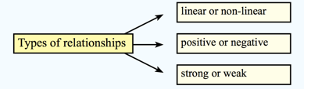
Direction | Form | Strength
POSITIVE RELATIONSHIP: | LINEAR: | STRONG:
NEGATIVE RELATIONSHIP: | PARTIALLY LINEAR: | WEAK:
NO RELATIONSHIP: | NON-LINEAR

